**Development of Multimodal Quantitative MRI Techniques to Assess Brain Tissue Microstructure in Multiple Sclerosis**

*Mathieu Boudreau*

*Supervisor: Bruce Pike*

PhD Progress Meeting

Biomedical Engineering Department

McGill University

**FINAL - 12/11/14 9:28 PM**

**1. Introduction and Objectives**

Multiple sclerosis (MS) is arguably the most disabling chronic neurological disease affecting a sizable portion of young adult Canadians. While the trigger of the disease is still unknown, considerable efforts have been made in the last few decades at investigating the progression of the pathology of MS. Magnetic resonance imaging (MRI) has emerged as an important imaging modality for diagnosing MS by detecting MS lesions and, in some instances, measuring multiple aspects of the disease. Some techniques provide mostly qualitative features such as T2 weighted images, but more recently quantitative measures of myelin and water content have been achieved with novel MRI techniques such as quantitative magnetization transfer (qMT) imaging and quantitative T2. Until now, most of the effort at characterizing MS with MRI has concentrated on white matter (WM) pathology, but recent post-mortem studies have emphasized the importance of cortical grey matter (GM) pathology to fully characterizing the disease. **In this thesis, we aim to develop a fast high-resolution whole-brain quantitative magnetization transfer method capable of characterizing white and gray matter MS pathology.**

**2. Abbreviated Literature Review**

**2.1 Multiple Sclerosis**

Canada has one of the highest occurrences of MS in the world. MS occurs mostly in women, with clinical onset typically beginning between ages 15-40 (1) and burdens the patient for their entire lifetime. MRI plays a crucial role in the diagnosis of MS, as described by the McDonald Criteria (last revised in 2010) (2). The most common type of MS is conventionally characterized as intermittent attacks of focal WM inflammation and demyelination (plaques), separated by periods of relative stability (3-5). Demyelination in MS WM is believed to be a result of an immunologically mediated attack on myelin and oligodendrocytes(4). Although MS has mostly been described as a WM disease, post-mortem histological evidence has shown many abnormalities in cortical GM of MS patients (6,7). GM lesions are characterized by demyelintation, axonal and dendritic transection, neuronal apoptosis and limited inflammatory cell content compared to WM lesions (8-12). One post-mortem study observed that 26% of MS lesions involved some GM (13). Another recent study reported that cortical GM pathology significantly correlated with neurological impairment in relapse-remitting MS patients (14). Despite this, most MRI techniques currently in use concentrate on WM lesions. The development of MRI methods capable of quantifying cortical GM pathology is important to fully characterize MS.

**2.2 Magnetic Resonance Imaging of MS**

MRI is well known to be very sensitive to various pathologies related to MS (2,7,15-21). The conventional MRI characteristic of MS is hyperintense signals in T2-weighted MRI of multiple focal WM lesions. However, T2 hyperintensity has little specificity to the lesion environment, as multiple pathological changes such as acute inflammation and axonal loss can lengthen T2. Conventional MRI also does not detect the full extent of MS pathology in regions referred to as normal appearing white matter (NAWM) and cortical GM. Brain atrophy, a common disease progression indicator for many neurological diseases such as MS, can also be quantified using MRI (14,22-25).

Cortical GM lesions typically elude MRI detection with clinical MRI scans (26,27). New techniques such as double inversion recovery (DIR) have shown better detection of cortical lesions. DIR uses two inversion pulses that null both WM and CSF, ideally leaving mostly GM signal (28). However, low SNR and CNR of DIR limit the detection of subtle cortical lesions.

**2.3 Quantitative MRI**

Quantitative MRI techniques, such as quantitative T1, T2, diffusion, and magnetization transfer, have become the focus of research development for MS due to their promise of providing hardware and site independent MRI measures and better MS diagnostic specificity (29). MT measures have been shown to strongly correlate with myelin content in brain white matter (16,17), and it is expected that a similar correlation with grey matter can be observed if resolution and SNR is improved (20).

**2.4 Magnetization Transfer**

Magnetization transfer (MT) is the MR phenomenon of nuclear spins in different environments exchanging magnetization through coupled relaxation (30-33). This method provides an indirect measurement of hydrogen in a semi-solid macromolecular state, as signal from these molecules is undetected with conventional MRI due to the characteristic fast signal decay of solids. This technique provides an indirect measurement of relative semi-solid (e.g. myelin) density. Although MT has been mostly used to investigate multiple sclerosis, other applications include HIV (34-36), Alzheimer’s disease (37-40), and articular cartilage (41,42).

The most simple and common magnetization transfer metric is the magnetization transfer ratio (MTR), which consists of two measurements: one with and one without an off-resonance saturation pulse. Although MTR has been shown to correlate with T1/T2 weighted MRI images and histology (16), quantitative methods using mathematical models of the magnetization transfer (31,43-47) can provide a more quantitative analysis of the disease. Schmierer et al. (17) compared qMT measurements with quantitative histology on post-mortem MS brains and observed that myelin density was strongly correlated with the restricted pool size ratio (F), and that F could distinguish between normal appearing WM and remyelinated WM lesions; however, cortical pathology was not examined. qMT MRI protocols have historically suffered from very long acquisition times due to the large number of measurements typically required. Several developments have been introduced to overcome this limitation, such as optimal sampling schemes (48,49), reduced sampling by parameter restricting (50,51) and novel qMT re-interpretations of rapid pulse sequences (52).

**2.5 Compressed Sensing**

Compressed sensing is an image compression technique whose underlying principles have recently been applied to MRI to accelerate image acquisition (53). It allows k-space data to be sampled below the Nyquist criteria while preserving image fidelity and SNR, and does not require major changes to MRI pulse sequence or new hardware. The basic idea behind compressed sensing is the following: **sparse signals may be accurately reconstructed from random k-space undersampling by solving a non-linear optimization problem.** There has been a rapid growth of the use of compressed sensing in the MRI community, with applications ranging from angiography (53), cardiac imaging (54) and diffusion spectrum imaging (55). Several model-based compressed sensing methods have been introduced to take advantage of sparsity in the parameter acquisition domain (56-58). Bayesian analysis has also been used for simultaneous multi-contrast compressed-sensing reconstruction (59,60). Lastly, an important branch of compressed sensing is the development of methods for multi-coil receivers (61-69).

**3. Thesis Hypotheses**

The major limitations to widespread use of the Sled and Pike qMT method is its very long acquisition times and single-slice acquisition. The low resolution of the protocol (2x2x7 mm3) also limits the confidence in cortical pathology measurements using this method. ***The next logical step is to develop a high-resolution whole-brain 3D qMT protocol able to confidently characterize cortical pathology in addition to white matter so that fundamental questions on the spatial progression of pathology in MS may be answered.***

To achieve this goal, I worked on two projects complimentary to Aim 1 (development of fast hi-resolution qMT) of the thesis hypotheses described in my 2012 project proposal. Results from these projects were presented at an international conference (ISMRM 2014, Milan, Italy), and received positive feedback. Following discussions with my thesis advisor (Dr. Bruce Pike) after the meeting, and some additional work over the course of the summer, we came to the mutual conclusions that this work warrants being reported as manuscripts. As such, due to the time invested on these projects, we decided to revise the proposed papers for the overall thesis. Nevertheless, the overall goal of the thesis presented above has not changed. Previously hypothesized Aims 2 (high-resolution post-mortem qMT of grey matter) and 3 (in-vivo diffusion and high resolution qMT in SPMS) have been removed from the PhD thesis proposal. Our research plan is now driven by the following hypotheses/questions:

1. ***Comparing quantitative transmit radiofrequency field (B1) mapping methods for whole-brain variable flip angle T1 maps***

Due to an increased interest in acquiring quantitative MRI measures (e.g. T1, qMT) with whole brain coverage, several novel rapid B1 mapping methods have gained considerable interest in the qMRI field. We present a comparison between the conventional double angle (DA) B1 method, two novel methods (Bloch-Siegert (BS), Actual Flip Angle Imaging (AFI)), and a k-space accelerated (EPI) DA method using a stock scanner sequence. Results show that all B1 sequences are adequate at producing comparable WM VFA T1 maps, with their variability well below that observed between T1 methods (70). Due to its easy implementation, k-space (EPI) accelerated DA B1 mapping using stock sequences should be considered as an important alternative to novel methods.

1. ***An analysis of the B1-sensitivity of qMT parameters***

For pulsed spoiled gradient echo (SPGR) qMT imaging experiments, B1 maps are used as a corrective factor for the excitation flip angle and MT saturation power. T1 mapping, also required for SPGR qMT, may require B1 maps as a corrective factor; variable flip angle (VFA) T1 mapping requires B1 maps, while inversion recovery (IR) does not. Thus, local (e.g. artifacts) or global (e.g. systemic biases) inaccuracies in B1 mapping will propagate to the fitted qMT parameters differently, depending on the chosen T1 mapping method. This work explores the sensitivity of qMT parameters to B1 inaccuracies through simulations and measurements at 3T using healthy subjects and an MS patient. We show that the pool-size ratio F is much more robust to B1 inaccuracies when using VFA, as opposed to IR. Thus, lower resolution B1 maps can be acquired (possibly even omitted) if VFA T1 mapping is used.

1. ***Quantitative MT acquisitions can be optimized for both white and grey matter sensitivity over the whole brain with a resolution of 1 mm3 in a clinically acceptable time of <30 minutes.***

Our current qMT protocol is based on a single-slice spoiled gradient echo (SPGR) sequence with many MT pulse power/offset/frequency/repetition time combinations. We will optimize our method for high resolution (1 mm3) whole-brain measurements at 3 T using a 32-channel head coil, optimal sampling scheme for normal/MS tissue properties at 3 T, and a novel compressed sampling imaging method to undersample k-space without losing integrity of the qMT maps. Comparisons between two compressed sampling methods and parallel imaging will be evaluated for efficiency in accelerating imaging and artifacts, and a whole-brain MS patient dataset will be acquired using this protocol.

**4. Thesis Work Progress**

**4.1 Quantitative Comparison of B1 Mapping Methods for White Matter T1 Mapping at 3T (90% complete)**

***Introduction:***The aim of this work was to compare VFA T1 maps in white matter (WM) produced with four B1 methods: Reference double angle (DA), Bloch-Siegert, Actual Flip-Angle Imaging, and DA using a stock scanner spin-echo EPI readout sequence (EPI-DA).

***Methods:***Prior to acquiring a set of subject data, several technical developments were made. Quantitative maps (B1, T1) processing code were standardized and integrated into an automated Matlab pipeline using MINC and Niak. The Bloch-Siegert sequence was updated to use off-resonance Fermi pulse, in accordance with the parameters reported in the original paper (71). To investigate the white matter T1, a majority voting analysis resampling script was developed to resample high-resolution tissue classification maps (WM, GM, CSF- provided via INSECT with the ICBM-152 atlas) to the low resolution (2x2x5 mm3) B1/T1 maps.

Six healthy adult subjects were scanned with a 3T Siemens Tim Trio MRI using a 32-channel receive-only head coil. Axial slices (2x2x5 mm3) were acquired (or extracted from 3D volumes) parallel to the AC-PC line above the corpus callosum. Quantitative analyses were done on the unfiltered (raw) B1 maps. The raw B1 maps were also filtered (Gaussian blurring and spline smoothing) for qualitative comparison (Fig. 4).

***Results:***To determine how each B1 maps compared in producing WM T1 maps, a single slice was extracted and masked for WM tissue for each subject prior to histogram and statistical analysis. We observed very little differences in overall WM T1 distribution when comparing against each B1 methods (Fig. 1). The largest deviation in T1 (mode) relative to the Reference DA B1 map was for EPI-DA (4% decrease). This deviation is substantially lower than those reported between T1 methods (IR, VFA, Look-Locker), which can vary up to 30% (70).

Each B1 methods are based off different pulse sequences (Ref. DA: spin-echo with full magnetization recovery, AFI: steady state, Bloch-Siegert: phase-based, EPI DA: fast k-space trajectory), which make them uniquely sensitive to different artifacts. Visual inspection of the B1 maps shows distinctive artifacts for our implementations of each method (Fig. 2a (bottom) and Fig. 4). No significant B1 maps distortions were observed in a sagittal EPI-DA B1 maps (Fig. 3).

Linear regression analysis of pooled WM T1 for each B1 relative to the reference is shown in Figure 5. The WM T1 produced by all rapid B1 methods correlated strongly (>0.97) with the Ref. DA. EPI-DA, the fastest of the B1 maps (5 s/slice), had no observable distortion artefacts (Figs. 2 and 3), due to careful sequence planning (low EPI factor, long echo spacing).

***Manuscript Progress:*** An initial draft the manuscript (technical report, Mag. Res. Med) is in progress, and will be distributed to the co-authors within a few weeks.

**4.2 B1-Sensitivity Analysis of qMT** **(80% Complete)**

***Introduction:***Quantitative magnetization transfer (qMT) imaging requires several additional measurements to correct for instrumental biases (B0, B1) and to constrain parameters in the fitting model (T1). These three extra measurements are typically independent of each other, but certain T1 mapping techniques also require B1 maps (e.g. variable flip angle – VFA). In this case, B1 is used twice before fitting the qMT parameters: to correct the flip angles for T1 mapping, and to scale the nominal MT saturation powers. Inaccuracies in B1 would propagate to the fitting of the qMT parameters through two pathways – through errors induced in T1, and errors in MT saturation powers. This work demonstrated that for the Sled and Pike SPGR qMT model, the pool-size ratio F much less sensitive B1 inaccuracies when using VFA for T1 mapping.

***Methods and Results:*** This study is separated into five stages to investigate the sensitivity of B1 inaccuracies on qMT parameters.

1. ***Noiseless simulation of single tissue qMT for B1/T1 inaccuracies***
2. ***B1-sensitivity of qMT parameters in-vivo***
3. ***Comparison using 3 B1 mapping methods***
4. ***B1-sensitivity of qMT parameters in pathology: RRMS patient***
5. ***Insights on the origin of the qMT F B1-insensitivity***

***Stage 1:*** The Bloch-McConnell equations for magnetization exchange were solved using MATLAB for a pulsed SPGR.Healthy white matter tissue parameters were fixed to normal values for 3T. The MT signal was simulated from the solution of the Bloch-McConnell equation for the uniform MT protocol (49). The MT signal was subsequently fitted using the Sled and Pike method for a linear range of 100 B1 and 100 T1 values. B1 ranged from 0.5 to 2 (B1,true = 1), and T1 ranged from 0.1 s to 4 s (T1,true = 0.9 s). Results are shown in Figs. 6 and 7. Errors in F induced by B1 errors were greatly reduced using VFA T1 mapping (Fig. 7a). This work recently was submitted as an abstract to ISMRM (Appendix 2).

***Stage 2:*** Three healthy adults were scanned with a 3T Siemens Tim Trio MRI using a 32-channel receive-only head coil. VFA and IRT1 maps were acquired. qMT data was acquired using the spoiled gradient echo two-TR uniform 10-point protocol for 3T (49). A double angle spin echo B1 map was acquired. To simulate B1 inaccuracies for a broader range of tissue values than Stage 1 (single tissue), flat (homogenous) B1 maps were produced, ranging from 0.5 to 2. VFA T1 maps and corrected MT saturation powers were then calculated from these flat B1. Note that VFA T1 calculated with a flat B1 factor of 1 is equivalent to fitting VFA T1 maps using the nominal flip angles. qMT maps were fitted with B1 maps using DA and flat B1, as well as IR T1 maps and VFA T1 maps. Whole-brain voxel data from all subjects were pooled for each qMT/T1/B1 sets, and linear regressions and correlations were calculated between B1 DA and every B1 Flat maps. Results are shown in Figs 8, 9, 10 and 11.

***Stage 3:*** In addition to using the data acquired in Stage 2, two additional B1 maps were acquired (Bloch-Siegert Shift (71), Actual Flip Angle Imaging (72,73)). The qMT maps were fitted for all three acquired B1 maps (unfiltered), using both VFA and IR B1 maps, and masked for WM in a similar procedure described in Section 4.1.

Figure 12 shows the histograms of WM F and kf, for VFA and IR. It can be clearly seen that the histograms of F values match best between all three B1 maps (prone to local inaccuracies, see Figs. 2 and 4) when using VFA. In agreement with simulations from Step 1 (Fig. 7b), better matching of the kf histograms occurs when using IR.

***Stage 4:*** A fully acquired whole brain (2x2x2 mm3) qMT data set (similar the one described in Step 2) of an MS patient was acquired in early December 2013 by two Pike lab members (Dr. Nikola Stikov and Dr. Jennifer Campbell), the data was generously be shared with me. The patient is a 38-year-old male subject with definite relapse-remitting MS (RRMS), EDSS 3.0. Analysis of this data is still a work in progress.

***Stage 5:*** An approximate sensitivity analysis was implemented using simulations (Figure 13). Comparing the sensitivity of both MT flip angles in the case of B1 errors using IR T2 (Fig. 13a) and VFA T1 (13b), it’s clear that F will be very stable in the fit for the case of VFA T1, as any changes in F requires induces large changes in both MT angles Z-spectrums. The sensitivity of the exchange rate kf matches that of the VFAcase, thus errors induced by B1 can be nearly completely compensated from this variable.

***Conclusion:*** The overall results of this work implies that B1 mapping may be completely eliminated from our qMT protocol by using VFA for T1 maps with no substantial biases on F, which could save up to 5-10 minutes from our 3D qMT protocol acquisition time.

**4.3 Analytical qMT Sensitivity Analysis (10% Complete, optional)**

Several methods of analyzing the source of the B1-insensitivity discussed in the previous section were explored – including a possible collaboration with Stephen Cauley (Harvard). I decided to pursue a system sensitivity analysis method (74), and a derivation for analytically analyzing the B1-sensitivity of qMT imaging is described briefly in Appendix A. I believe that a comprehensive analysis of this type is out of the scope of the paper proposed in Section 4.3, but is indicated as being optional here in the case a reviewer requests its inclusion.

**4.4 qMT Compressed Sensing (20% Complete)**

The compressed sensing k-space acceleration project is still a work in progress. Sparse k-space pulse sequence acquisition was developed with Raphaël Paquin (Siemens scientist). The method was successfully developed to the stock Siemens 2D gradient echo pulse sequence (the base sequence for our qMT sequences), with the capability of reading the k-space lines to be acquired from a text file, allowing for great at-the-scanner flexibility. This feature needs to be extended to 3D and merged with our qMT sequence. To aid in this transition, an additional feature to the qMT sequence was developed to allow single point acquisitions instead of full qMT protocols, and user interface MT parameter control (MT saturation, off-resonance frequency). Additionally, as raw (k-space) data from all 32 channels must be used for compressed sensing, Matlab code was developed to organize the loaded raw data into k-space and/or image domain matrices using the measurement data headers. Lastly, an open source L1-SPIRIT (61,63) multi-channel sparse acquisition image reconstruction software package was installed and tested on one of our lab computers. This software significantly accelerates multi-channel L1-Spirit processing through the use GPU processing or OpenMP multi-processor tools. . Raw single slice (2x2x5 mm3) k-space data (fully acquired) of our optimal 10-point qMT protocol has been acquired for 5 healthy subjects as part of another study (Sections 4.1 and 4.2). This data set will be helpful in evaluating compressed sensing artefacts that may result in the loss of lesion information in fitted qMT maps.

**4.5 Other – 2014 Training and Collaborations**

Throughout this year, I had the opportunity to participate in several training opportunities. The abstract submitted for the 2013 endMS conference was accepted, and I was awarded a scholarship covering the complete cost of attending the conference in Saint-Sauveur. This conference was a great opportunity to network and discuss with interdisciplinary Canadian MS researchers, and contained many trainee-oriented sessions (e.g. a communication workshop by the Alan Alda Center for Communicating Science). Both abstracts submitted last year for the 2014 ISMRM meeting were also accepted: a traditional poster and an electronic poster. I was awarded an ISMRM Trainee Educational Stipend to attend the meeting in Milan and the weekend educational course that preceded the meeting. Throughout the year, I attended several endMS Network workshop organized at the MNI, such as the four-session endMS Statistics Series. I also attend and a Software Carpentry workshop in January (Montrea), and the 2014 MS Exchange conference November (Montreal).

Following the gradual departure of Ye Gu and Dr. Nikola Stikov from our lab, my experience with acquiring and processing qMT data allowed me to collaborate with many local and international researchers. I acquired and analyzed a whole-brain RRMS data set for Dr. Nikola Stikov and Dr. Jennifer Campbell (Montreal Neurological Institute), and was granted co-authorship in a recently submitted manuscript (Appendix D). Dr. Stikov also requested my assistance for preliminary data for a research grant application in collaboration with Dr. Julien Cohen-Adad (Polytechnique Montreal). Over several months, I was involved with planning, acquiring, and analyzing qMT data in pig and cat spinal cords on our human 3T MRI at the MNI, and the animal 7T scanner at the Montreal Heart Institute. Co-authorship was not attributed in any conference abstracts or papers for my assistance in this project. I provided technical assistance and troubleshooting to Dr. Jacqueline Chen (Lerner Research Institute, Cleveland, Ohio) regarding the implementation of an AFI B1 mapping acquisition and analysis on their 3T Siemens scanner. At the request of Dr. Stikov, I explored a possible collaboration with Dr. Aviv Mezer (Stanford University) involving the efficacy of fitting the MT exchange rate kf by fixing F in the model using his macromolecular tissue volume biomarker for myelin (75). I assisted Dr. David Rudko and Dr. Robert Brown (Montreal Neurolotical Institute) with acquiring and analyzing qMT data using our qMT software. I am currently in an on-going collaboration with Melany Ann McLean (University of Calgary, Dr. Pike’s lab), assisting with qMT data analysis development for a small animal project.

**5. Thesis Completion Plan**

**5.1 First Thesis Paper: *Quantitative Comparison of B1 Mapping Methods for White Matter T1 Mapping at 3T***

This project is near completion. The manuscript is already in progress, and no additional measurements are expected prior to submission of this work.

**5.2 Second Thesis Paper: *B1-Sensitivity Analysis of qMT***

This project is also near completion. Only minor analysis work of the MS patient data is left to do prior to submission. No additional measurements are expected prior to submitting the manuscript.

**5.3 Third Thesis Paper: *Analytical Analysis of B1-Sensitivity of Quantitative Magnetization Imaging***

A sensitivity analysis (74) derivation for analytically analyzing the B1-sensitivity of qMT imaging is described briefly in Appendix A. Sensitivity analyses will be evaluated for several established qMT imaging protocols, using the B1-independent T1 assumption as well as VFA T1. The analytical solution of the pulsed qMT sequence under established assumptions will be used for the sensitivity analysis. The effects on the B1-sensitivity of constraining certain parameters, as have been recently proposed (50), will be explored. Lastly, the possibility of optimizing the qMT acquisition protocol for minimum B1-sensitivity will be explored, with the aim of achieving a qMT protocol without a B1 map.

**5. 4 Fourth Thesis Paper: *Accelerated qMT Using Compressed Sensing***

The next step in the completion of the final paper of this thesis will be to establish a compressed sensing image reconstruction technique for our qMT pulse sequence. This may involve a collaboration with Dr. Ives Levesque, an alumni of Dr. Pike’s lab, and a medical imaging physicist who has recently joined McGill University as an assistant professor at the McGill University Health Center.

The first step will be to investigate the sensitivity of each qMT Z-spectrum acquisitions to compressed sensing related artifacts that propagate into the final qMT fitted parameter maps. This will be investigated using the open source L1-SPIRIT+Wavelet reconstruction processing code mentioned in Section 4.4. K-space data will be retroactively undersampled at different acceleration factors for each qMT point, then each point will be individually reconstructed and fitted for qMT parameters with the other fully sampled qMT points.

Once the L1-SPIRIT qMT acquisition sensitivity has been established, an alternative compressed sensing method developed for quantitative parameter mapping using locally low rank constraints (76), will be evaluated for qMT and compared to our L1-SPIRIT analysis. This method takes advantage of the data redundancy in the MRI parameter domain (e.g. for T2 measurements, the parameter being varied is TE) through sparsity in the singular values of a Casorati matrix (column is the image voxel dimension, row is the parameter dimensions). This method is a model-free parameter-domain compressed sensing method, and may promise to be more efficient at accelerating acquisition than the L1-Spirit method, which does not take into account of parameter domain redundancy. The comparison and optimization of these two methods qMT (and possibly parallel imaging acceleration) using will be written as a full paper.

**6. Timeline for Completion of Thesis**

**6.1 January 2014-February 2015**

The overall thesis completion timeline is shown in Fig. 14. The first thesis paper (“*A Comparison of B1 Mapping Methods for T1 Mapping at 3T*”) has already been in the writing process and is nearing completion of the first draft. I anticipate distributing a draft to co-authors by mid-January. While it circulates for corrections, I will write the second thesis paper (“*B1-Sensitivity Analysis of qMT*”), which only minor data analysis in a section remains. My aim is to submit both these papers by March 2015.

**6.2 March 2015 - September 2015**

The optional third paper (Section 8 - Chapter 5, *Analytical B1 Sensitivity Analysis of qMT*) will be worked on over the following six months, but priority will be given to the final and fourth paper. This work will only result in its own manuscript if the reviewers for our second manuscript (Section 8, Chapter 4) do request its inclusion in that manuscript.

The target completion date for the final (fourth paper) is September 2015. March 2015 and April 2015 will be spent investigating the qMT Z-spectrum point sensitivity on retroactive compressed sensing reconstruction. Healthy subject data (N = 5) has already been acquired, and multi-coil L1-Spirit GPU reconstruction code is already openly available and will be used. If possible, compressed sensing reconstructions effect on lesions will be explored with raw qMT data of a few RRMS and/or SPMS MS patients that may have been collected by Dr. David Rudko, a post-doctoral fellow in Dr. Arnolds lab, if the data is available. Locally low rank (LLR) sparsity reconstruction for parameter MRI mapping will be evaluated for qMT in May and June 2015. Both LLR and L1-SPIRiT will be compared in a small in vivo investigation using a whole-brain qMT data set of healthy subjects in July and August 2015.

**6.3 October 2015 - December 2015**

The final and fourth research paper will be written and submitted by December 2015. The remaining thesis chapters (Introduction, Background, Conclusion) will also be written between October and December 2015. My goal is to submit my PhD thesis by the December 15th 2015 term deadline.

**7. PhD Publications and Conference Proceedings**

**7.1 Published Manuscripts**

1. Nikola Stikov, **Mathieu Boudreau**, Ives Levesque, Christine Tardif, Joëlle Barral, G. Bruce Pike, *“On the Accuracy of T1 Mapping: Searching for Common Ground”*, Magnetic Resonance in Medicine, DOI: 10.1002/mrm.25135 (2014)

**7.2 Submitted Manuscripts**

1. Nikola Stikov, Jennifer S.W. Campbell, Thomas Stroh, Stephen Frey, Jennifer Novek, Stephen Nuara, Ming-Kai Ho, Barry J. Bedell, Robert F. Dougherty, Ilana R. Leppert, **Mathieu Boudreau**, Sridar Narayanan, and G. Bruce Pike, *“In vivo histology of the myelin g-ratio with magnetic resonance imaging”*, Neuroimage, (Submitted on: December 5th 2014)

**7.3 Manuscripts in Progress**

1. **Mathieu Boudreau**, Christine Tardif, Nikola Stikov, G. Bruce Pike, *“A Comparison of B1 Mapping Methods for T1 Mapping at 3T”*, Proposed submission to: Magnetic Resonance in Medicine, Format: Technical Note (2015)
2. **Mathieu Boudreau**, Nikola Stikov, Douglas L. Arnold, G. Bruce Pike, *“B1-Sensitivity Analysis of qMT”*, Proposed submission to: Magnetic Resonance in Medicine, Format: Full Paper (2015)

**7.4 Proposed Manuscripts**

1. **Mathieu Boudreau**, Nikola Stikov, Stephen Cauley, G. Bruce Pike, *“Analytical Analysis of B1-Sensitivity of Quantitative Magnetization Imaging”*, Proposed submission to: Medical Physics, Format: Technical Note (2015)
2. **Mathieu Boudreau**, Ives R. Levesque, David Rudko, Tao Zhang, Douglas L. Arnold, G. Bruce Pike, *“Optimized Acceleration of Quantitative Magnetization Transfer Parameter Mapping Using Locally Low Rank Sparsity”*, Proposed submission to: Magnetic Resonance in Medicine, Format: Full Paper (2015)

**7.5 Peer Reviewed Conference Abstracts**

1. N. Stikov, J. Campbell, **M. Boudreau**, S. Narayanan, T. Stroh, S. Nuara, J. Novek, S. Frey, M.-K. Ho, B. Bedell, G. B. Pike, “*In vivo histology of the myelin g-ratio”*, Poster, OHBM Annual Meeting (2014)
2. **Mathieu Boudreau**, Nikola Stikov, G. Bruce Pike, *“A B1 Insensitive qMT Protocol”*, Poster, International Society for Magnetic Resonance in Medicine Meeting (2014)
3. **Mathieu Boudreau**, Christine Tardif, Nikola Stikov, G. Bruce Pike, *“A Comparison of B1 Mapping Methods for T1 Mapping at 3T”*, E-Poster, International Society for Magnetic Resonance in Medicine Meeting (2014)
4. **Mathieu Boudreau**, Nikola Stikov, G. Bruce Pike, *“Effect of Different T1 Mapping Techniques on a Quantitative Magnetization Transfer MRI Biomarker for Myelin Density”*, Poster, endMS Conference (2013)
5. **Mathieu Boudreau**, Nikola Stikov, G. Bruce Pike, *“T1 Mapping: Should We Agree To Disagree?”,* Poster, International Society for Magnetic Resonance in Medicine Meeting (2013)

**7.6 Submitted Conference Abstracts**

1. **Mathieu Boudreau**, Nikola Stikov, G. Bruce Pike, *“B1-Sensitivity Analysis of qMT”*, Submitted to: International Society for Magnetic Resonance in Medicine Meeting 2015
2. Ye Gu, **Mathieu Boudreau**, Ives R Levesque, Yaaseen Atchia, John Sled, Sridar Narayanan, Douglas L. Arnold, Bruce Pike, and Nikola Stikov, *“Quantitative Magnetization Transfer Analysis: An Interactive Introduction with qMTLab”*, Submitted to: International Society for Magnetic Resonance in Medicine Meeting 2015

**8. Thesis Draft Outline**

**Chapter 1: Introduction**

Motivation for the thesis work will be introduced in Chapter 1. Broad facts about the current knowledge of MS will be discussed at a level accessible to non-experts. Previous MRI limitations leading to the technical developments of this thesis will be discussed. The broad aim of this thesis will be stated.

**Chapter 2: Background**

Chapter 2 will cover the background required to understand the following integrated articles at level accessible to MS and MRI researchers. White matter MS pathology will be discussed, following by the current state of knowledge of cortical grey matter MS pathology. An overview of the current state of quantitative MRI techniques (B0 B1, and T1) will be presented. Quantitative magnetization transfer MRI will be explained in detail, and relevant recent studies will be presented. The compressed sensing technique will be described in detail, and a comparison between methods will be presented.

**Chapter 3: (Integrated article, Technical Note) *qMT B1 Insensitivity when using VFA T1 Maps***

Chapter 3 will contain the *published* journal article presenting a comparison of B1 techniques and their application to VFA T1 mapping. The audience of the paper will be researchers seeking to integrate whole brain B1 mapping in their study protocols. The main aim of this paper is to demonstrate that k-space (EPI) double angle B1 imaging is a sufficient alternative to recent novel B1 methods for whole brain imaging, and correlates better to the reference double angle B1 method. A short discussion on filtering B1 maps will be presented.

**Chapter 4: (Integrated article, Full Paper) *B1-Sensitivity Analysis of qMT***

Chapter 4 will contain the *published* journal article presenting an analysis of the B1 sensitivity of qMT parameters under two regimes: B1-independent T1 mapping (e.g. IR) and B1-dependent T1 mapping (e.g. VFA). Simulations will be presented to establish under ideal circumstances the qMT sensitivity of B1 inaccuracies. MRI measurements of a small set of healthy subjects will be presented: 1) a comparison double angle and simulated variable amplitude flat B1 maps, and 2) a comparison between three B1 mapping methods. Similar analysis will be demonstrated on a whole brain qMT data set of an RRMS patient. A rudimentary sensitivity analysis will be discussed to provide insights on the origin and extent of the B1-insensitivity of the pool-size ratio.

**Chapter 5: (Integrated article, Technical Note, Optional) *Analytical Analysis of B1-Sensitivity of Quantitative Magnetization Imaging***

Chapter 5 may contain the *submitted* journal article presenting a thorough B1-sensitivity analysis of qMT using analytical equations and/or simulated data. It is noted as optional, as it may be included in Chapter 4 if requested by the reviewers. The effects of fixing qMT parameters, which is proposed by some groups, will also be explored and reported.

**Chapter 6: (Integrated article, Full Paper) *Optimized Acceleration of Quantitative Magnetization Transfer Parameter Mapping Using Locally Low Rank Sparsity***

Chapter 6 will contain the *submitted* journal article presenting a parameter-based compressed sensing reconstruction method applied to quantitative magnetization transfer. Single slice healthy subject data will be retroactively undersampled, and each qMT measurement will be individually assessed for sensitivity to L1-Spirit compressed sensing artifacts, and a measurement-varying k-space sparse acquisition protocol will be developed. Locally low rank sparsity reconstruction will then be evaluated and compared to the optimal L1-Spirit method developed. Lastly, qMT parameter contrast in WM lesions will be compared for both method using data from one (more if available) MS patient using the completed fast 3D protocol.

**Chapter 7: Conclusion**

The final chapter will summarize the thesis work, and provide concise conclusions at a level understandable to non-experts. Future work made feasible due to the technical developments of the thesis will be discussed.

**FIGURES**



**Figure 1.** Normalized pooled histograms of single slice WM T1 values for 6 healthy subjects (bin width = 10 ms).



**Figure 2.** (Top) Raw B1 acquisition images for each method. (Bottom) (a) Single slice B1 maps from a representative subject. (b) WM VFA T1 maps using flip angles corrected with each B1 map.



**Figure 3.** Sagittal (left hemisphere) B1 maps for a single subject using the reference and EPI double angle methods.



**Figure 4.** Comparison between raw B1 maps and filtered maps using: (**a**) Gaussian blurring (**b**) spline smoothing.

**Figure 5:** Table listing the linear regression analysis of the pooled WM T1 values (6 subjects) for each B1 method relative to the reference DA B1 method.

|  |  |  |  |  |
| --- | --- | --- | --- | --- |
|  | **Ref. DA** | **BS** | **AFI** | **EPI-DA** |
| **Pearson ρ** | ----------- | 0.97 | 0.97 | 0.99 |
| **Fit slope** | ----------- | 0.98 | 1.00 | 0.97 |

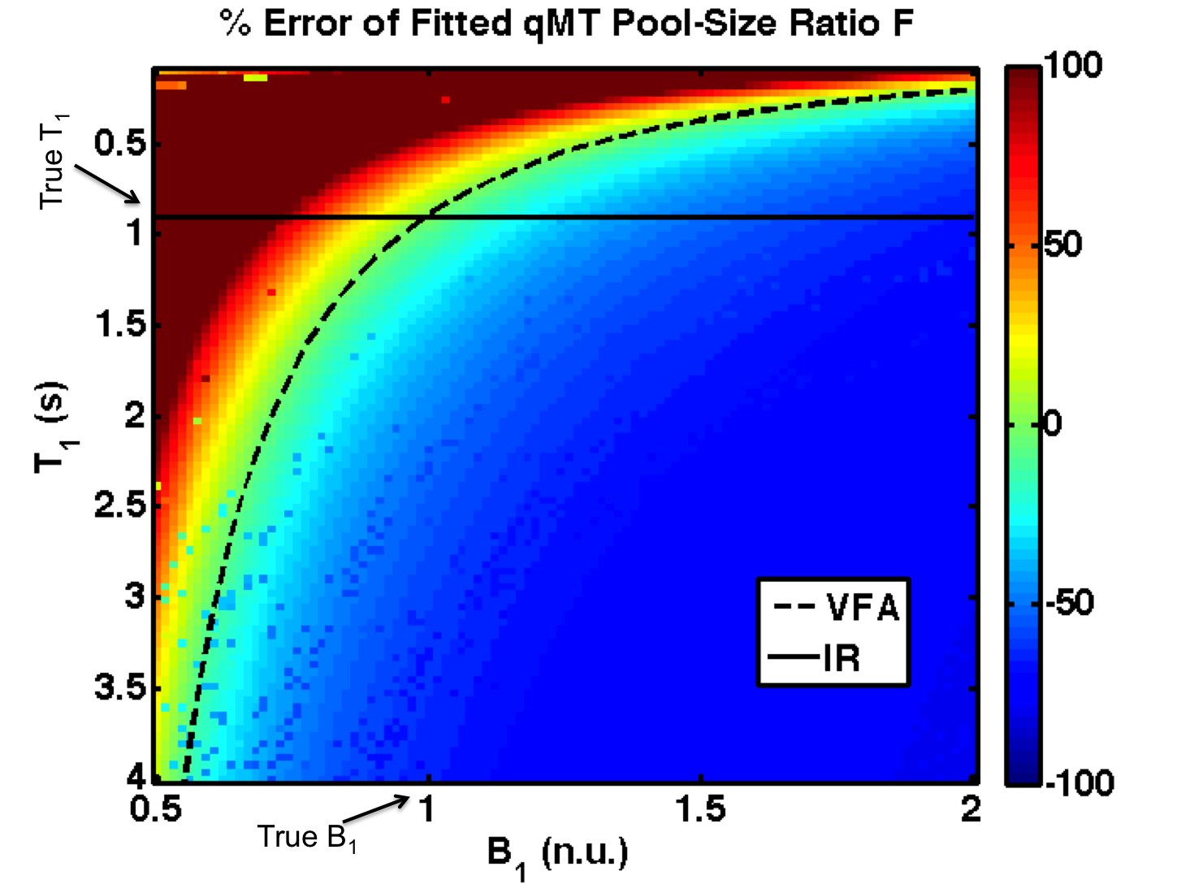

**Figure 6:** Percent error in fitted qMT F values in the presence of a wide range of B1 and T1 errors (B1,true = 1 n.u., T1,true = 0.9 s). The superimposed lines plot the T1 distribution for a B1-independent T1 mapping method (IR, solid line) and VFA (dashed line).

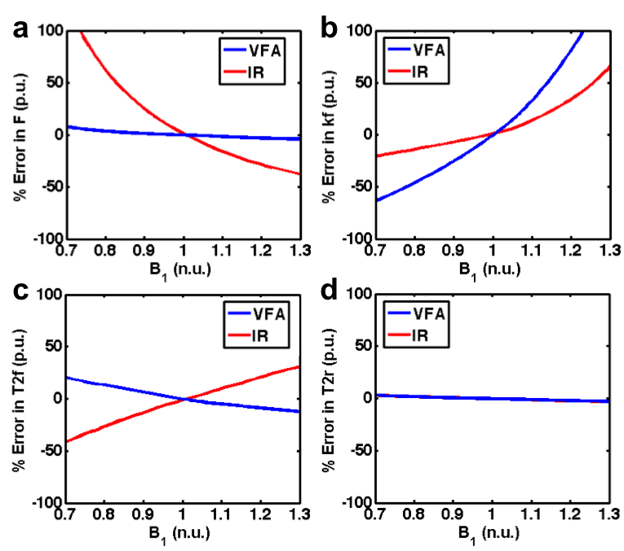

**Figure 7:** Percent error in fitted qMT parameters for a range of B1 errors (**a** – pool size ratio (F), **b** – magnetization exchange rate (kf), **c** – free pool T2 (T2f), **d** – restricted pool T2 (T2r)). Fits using a B1-independent T1 measure (IR) are shown in red, and those using VFA T1 mapping are shown in blue. See solid and dashed lines in Fig. 2 for B1 dependence of IR and VFA T1.

** Figure 8:** A single subject comparison of qMT F maps fitted using DA and flat (B1 = 1) B1 maps using (**a**) VFA T1 maps corrected using the corresponding B1 map and (**b**) IR T1 maps independent of B1.



**Figure 9: a** – Histogram of B1 error in the nominal B1 (Flat B1 = 1) assumption relative to the DA B1 map in a single subject. **b** – Histogram of fitted qMT F error % between nominal and DA B1 map, when using IR (red) or VFA (blue) T1 mapping. **c** – Histogram of fitted qMT kf error % between nominal and DA B1 map, when using IR (red) or VFA (blue) T1 mapping.

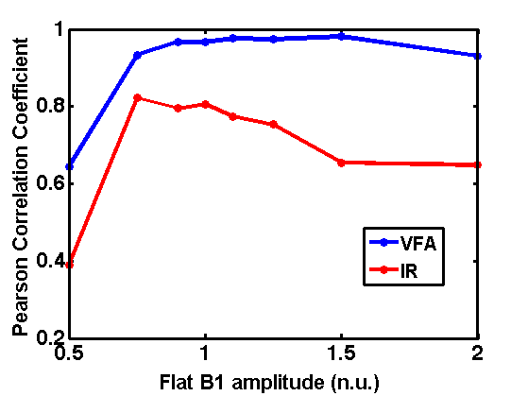 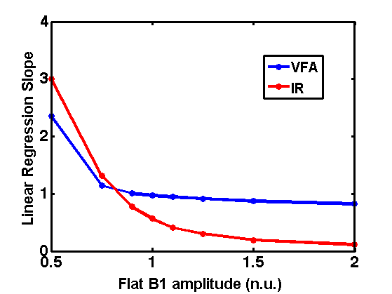

**Figure 10:** Pooled (all subjects) whole brain Pearson correlation coefficients (a) and linear regression slopes (b) for qMT F values between the measured DA B1 maps and simulated flat B1 maps.

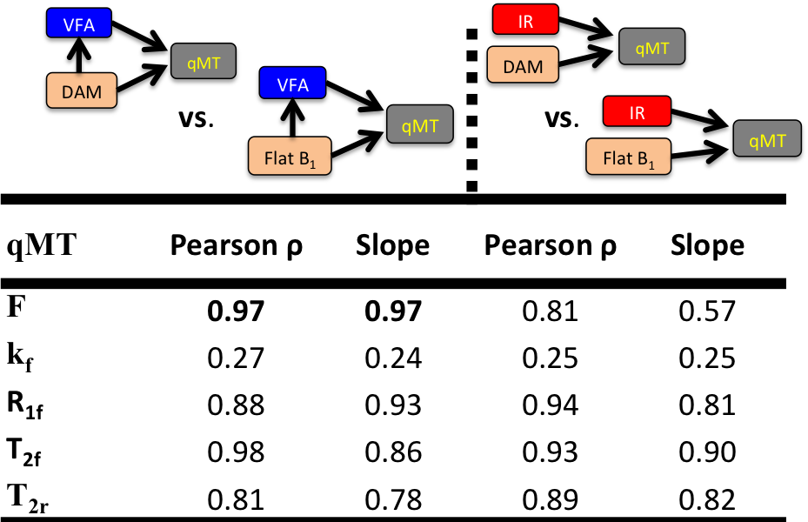

**Figure 11:** Pooled (all subjects) whole brain Pearson correlation coefficients and linear regression slopes for qMT F values between the measured DA B1 maps and simulated flat B1 maps.

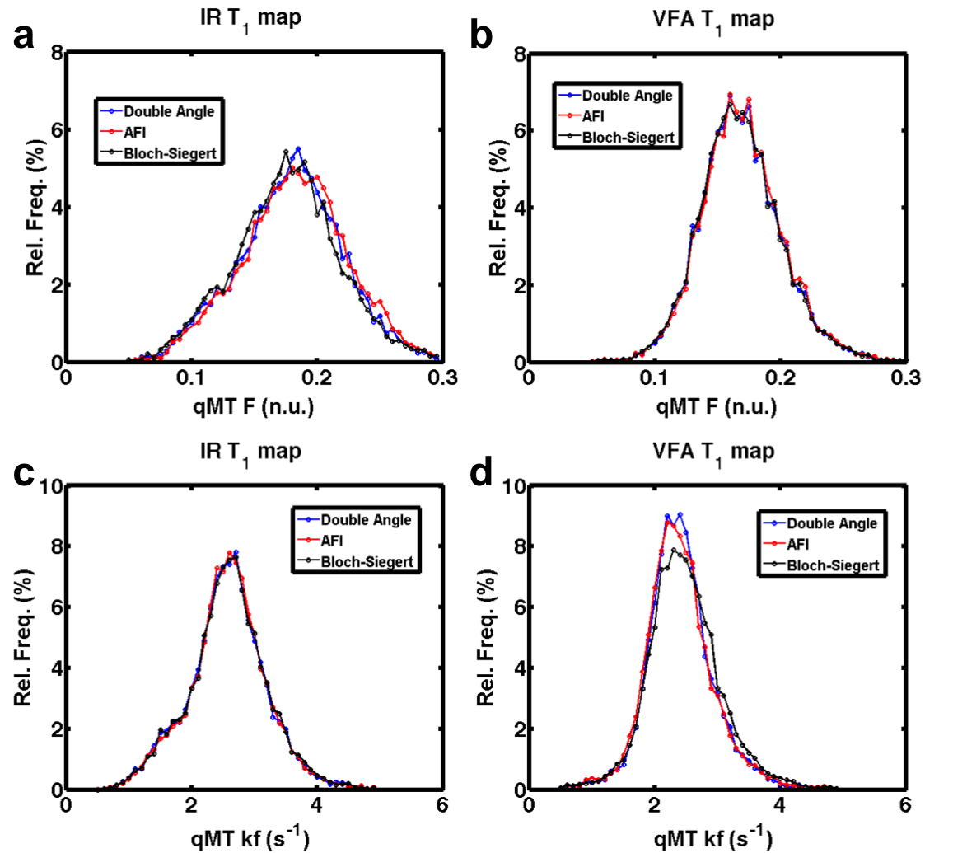

**Figure 12:** Single-subject WM pool-size ratio (**a**, **b**) and exchange coefficient (**c**, **d**) distributions for 3 B1 mapping methods, using IR T1 mapping (**a**, **c**) and VFA T1 mapping (**b**, **d**).

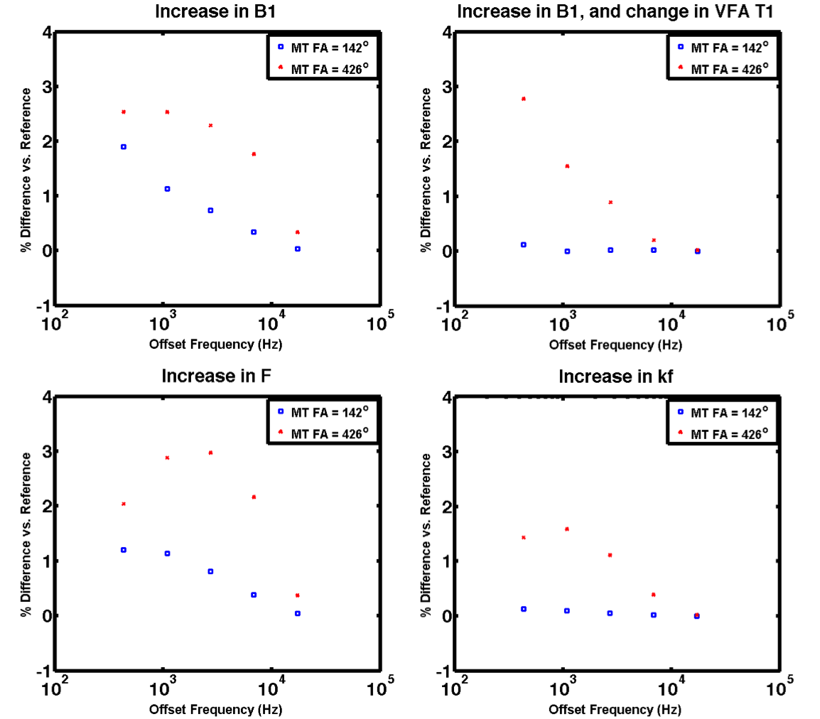

**Figure 13:** Sensitivity analysis of the MT signal for changes in tissue or fitting variables: **a** – 5 % increase in B1relative to the true B1, T1 independent of B1 **b** – 5 % increase in B1relative to the true B1, T1 dependent of B1 (VFA) **c** – 10% increase in the pool-size ratio F **d** – 10% increase in the MT exchange coefficient kf.

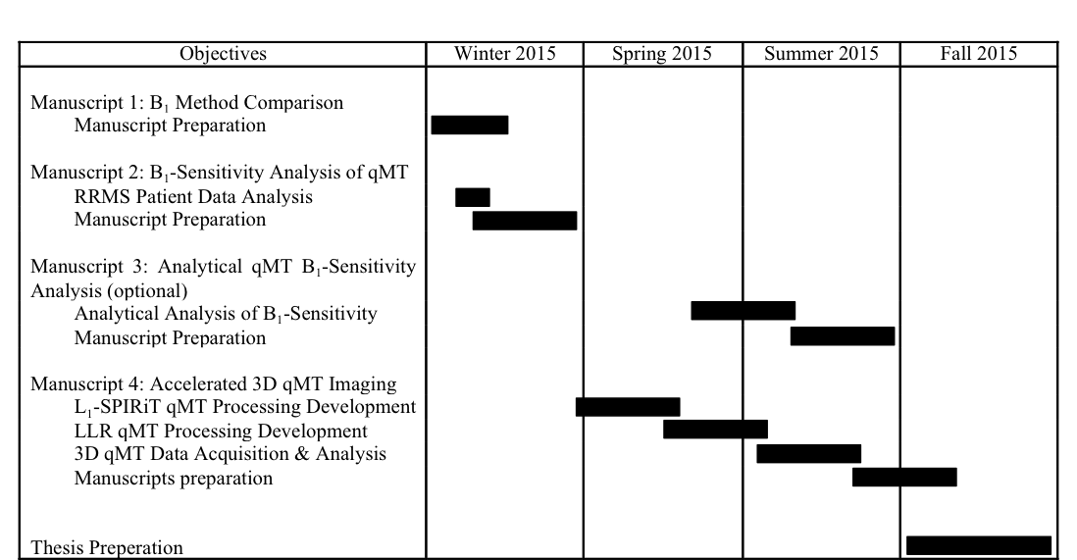

**Figure 14.** Estimate timeline for the completion of the PhD thesis.

**APENDIX A**

**Derivation of Method to Analytically Analyze Sensitivity of qMT to B1 Inaccuracies**

Let there be N measurements *Mmeas*, with each measured point being approximated well by a fitted value *Mfi*t dependent on L fitting or/and input variables $φ$:

$$\left[\begin{matrix}M_{1,fit}\left(φ_{1},…,φ_{L}\right) \\ ⋮ \\ M_{N,fit}\left(φ_{1},…,φ_{L}\right)\end{matrix}\right]≅\left[\begin{matrix}M_{1,meas} \\ ⋮ \\ M_{N,meas}\end{matrix}\right]$$

In the case of a small error in a measured input variable $φ_{j,meas}$, the change in a fitted value of Mi can be approximated by a Taylor expansion:

$$M_{i,fit}\left(φ_{j,meas}+Δφ_{j,meas}\right)=M_{i,fit}\left(φ_{j},meas\right)+\sum_{k=1}^{L}{\frac{∂M_{i,fit}}{∂φ_{k}}Δφ_{k}}+…$$

As we always fit the model to the original fitted measurement values, and we assume a good fit:

$$M_{i,fit}\left(φ_{j,meas}+Δφ_{j,meas}\right)≅M_{i,meas}≡M_{i}$$

and

$$M_{i,fit}\left(φ_{j,meas}\right)≅M_{i,meas}≡M_{i}$$

such that

$$M_{i}≅M_{i}+\sum_{k=1}^{L}{\frac{∂M_{i}}{∂φ_{k}}Δφ_{k}}$$

Thus, any error caused by $Δφ_{j,meas}$ is compensated by variations in the other fitted parameters $Δφ_{k}$:

$$\sum_{\begin{aligned}k=1 \\ k≠j\end{aligned}}^{L}{\frac{∂M_{i}}{∂φ_{k}}Δφ_{k}+\frac{∂M_{i}}{∂φ_{j,meas}}Δφ_{j,meas}}=0$$

$$\sum_{\begin{aligned}k=1 \\ k≠j\end{aligned}}^{L}{\frac{∂M_{i}}{∂φ_{k}}Δφ_{k}}=-\frac{∂M_{i}}{∂φ_{j,meas}}Δφ_{j,meas}$$

For qMT, the measurement we are interested in as a possible source of error is B1, and the fitted parameters are F, kf, T2f and T2r (T1,f is omitted, it’s simply a function of T1,meas, F, and kf)

The sensitivity function is defined as:

$$S_{φ_{k},i}≡\frac{∂M_{i}}{∂φ_{k}}$$

Such that the previous equation can be writing compactly as:

$$\begin{matrix}\left[\begin{matrix}S_{F,i} & S_{k_{f},i}\end{matrix} \begin{matrix}S_{T_{2,f},i} & S_{T_{2,r},i}\end{matrix}\right] \\ \\ \begin{matrix} \\ \end{matrix}\end{matrix}\left[\begin{matrix}ΔF \\ Δk_{f} \\ \begin{matrix}{ΔT}_{2,f} \\ {ΔT}_{2,r}\end{matrix}\end{matrix}\right]=-S_{B_{1},i}ΔB_{1}$$

From this equation, we can provide the following general observations:

1. The larger the sensitivity functions $S_{φ_{k},i}$, the less variation $Δφ_{k}$ (e.g. $ΔF, Δk_{f}, …)$ is required for $φ_{k}$ (e.g. $F, k_{f}, …)$ to compensate the error caused by $Δφ_{j,meas}$ (e.g. $ΔB_{1}$) .
2. The smaller the sensitivity function for the measurement $S_{φ_{k},i}$ (e.g. $S_{B_{1},i}=\frac{∂M_{i}}{∂B_{1}}$) , the less overall compensation is required by all the $φ_{k}$ (e.g. $F, k_{f}, …)$.
3. $S_{B_{1},i}$ will depend on the T1 mapping method (e.g , ), due to the B1 dependence of VFA and B1 independence of IR T1 maps.

For a set of N measurements (for our qMT protocols, N=10), this equation expands to:

$$\left[\begin{matrix}S_{F,1} \\ ⋮ \\ S_{F,N}\end{matrix}\begin{matrix}S_{k_{f},1} \\ ⋮ \\ S_{k_{f},N}\end{matrix}\begin{matrix}S_{T_{2,f},1} \\ ⋮ \\ S_{T_{2,f},N}\end{matrix}\begin{matrix}S_{T_{2,r},1} \\ ⋮ \\ S_{T_{2,r},N}\end{matrix}\right]\left[\begin{matrix}ΔF \\ Δk_{f} \\ \begin{matrix}{ΔT}_{2,f} \\ {ΔT}_{2,r}\end{matrix}\end{matrix}\right]=\left[\begin{matrix}{-S}_{B_{1},1} ΔB_{1} \\ ⋮ \\ {-S}_{B_{1},N}ΔB_{1}\end{matrix}\right]$$

Which can be written in matrix form:

$$Sψ=Ψ$$

where S is the matrix of sensitivity functions, $ψ$ is the vector of changes in fitted parameters, and $Ψ$ is the vector of ${-S}_{B_{1},i}ΔB_{1}$.

As the equation is an overdetermined set of linear equations of the form:

$$Ax=b$$

The optimal changes in parameters $ψ$ can be solved through the following minimization:

$\min{{\left\|Sψ-Ψ\right\|}_{2}^{2}}$

for different protocols, B1 mapping methods, etc. $S$ and $Ψ$ can be calculated analytically (possible, but cumbersome to do so), or estimated through simulations.

From this analysis, and from my qMT B1-insensitivity measurements, we can make the following general predictions:

* $\left|S_{F,i}\right|≫\left|S_{k_{f},i}\right|$ for most measurements when using VFA, since we expect $ΔF≅$ 0
* $\left|S_{k_{f},i}\right|≪\left|S_{F,i}\right|,\left|S_{T_{2,f},i}\right|,\left|S_{T_{2,r},i}\right|$ for most measurements when using VFA (most of the error is dumped into kf)
* $\left|S_{B_{1},i}^{VFA}\right|< \left|S_{B_{1},i}^{IR}\right|$ since less $ΔF$ is required for VFA and IR. (This one is less strong, since $Δk_{f}$ is smaller for IR and VFA, but for $ΔF$ it’s the opposite. Possibly a more complicated relationship to the solution of minimization instead of this simple relation)

**APENDIX B**

**2015 ISMRM Conference Abstract – 1**

**(Submitted, First author)**

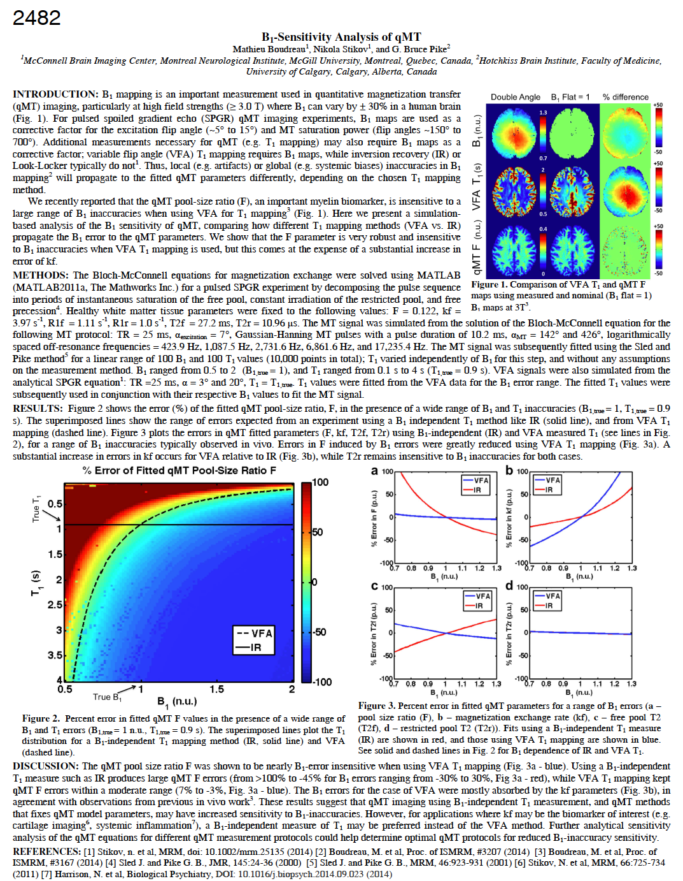

**APENDIX C**

**2015 ISMRM Conference Abstract – 2**

**(Submitted, coauthor)**

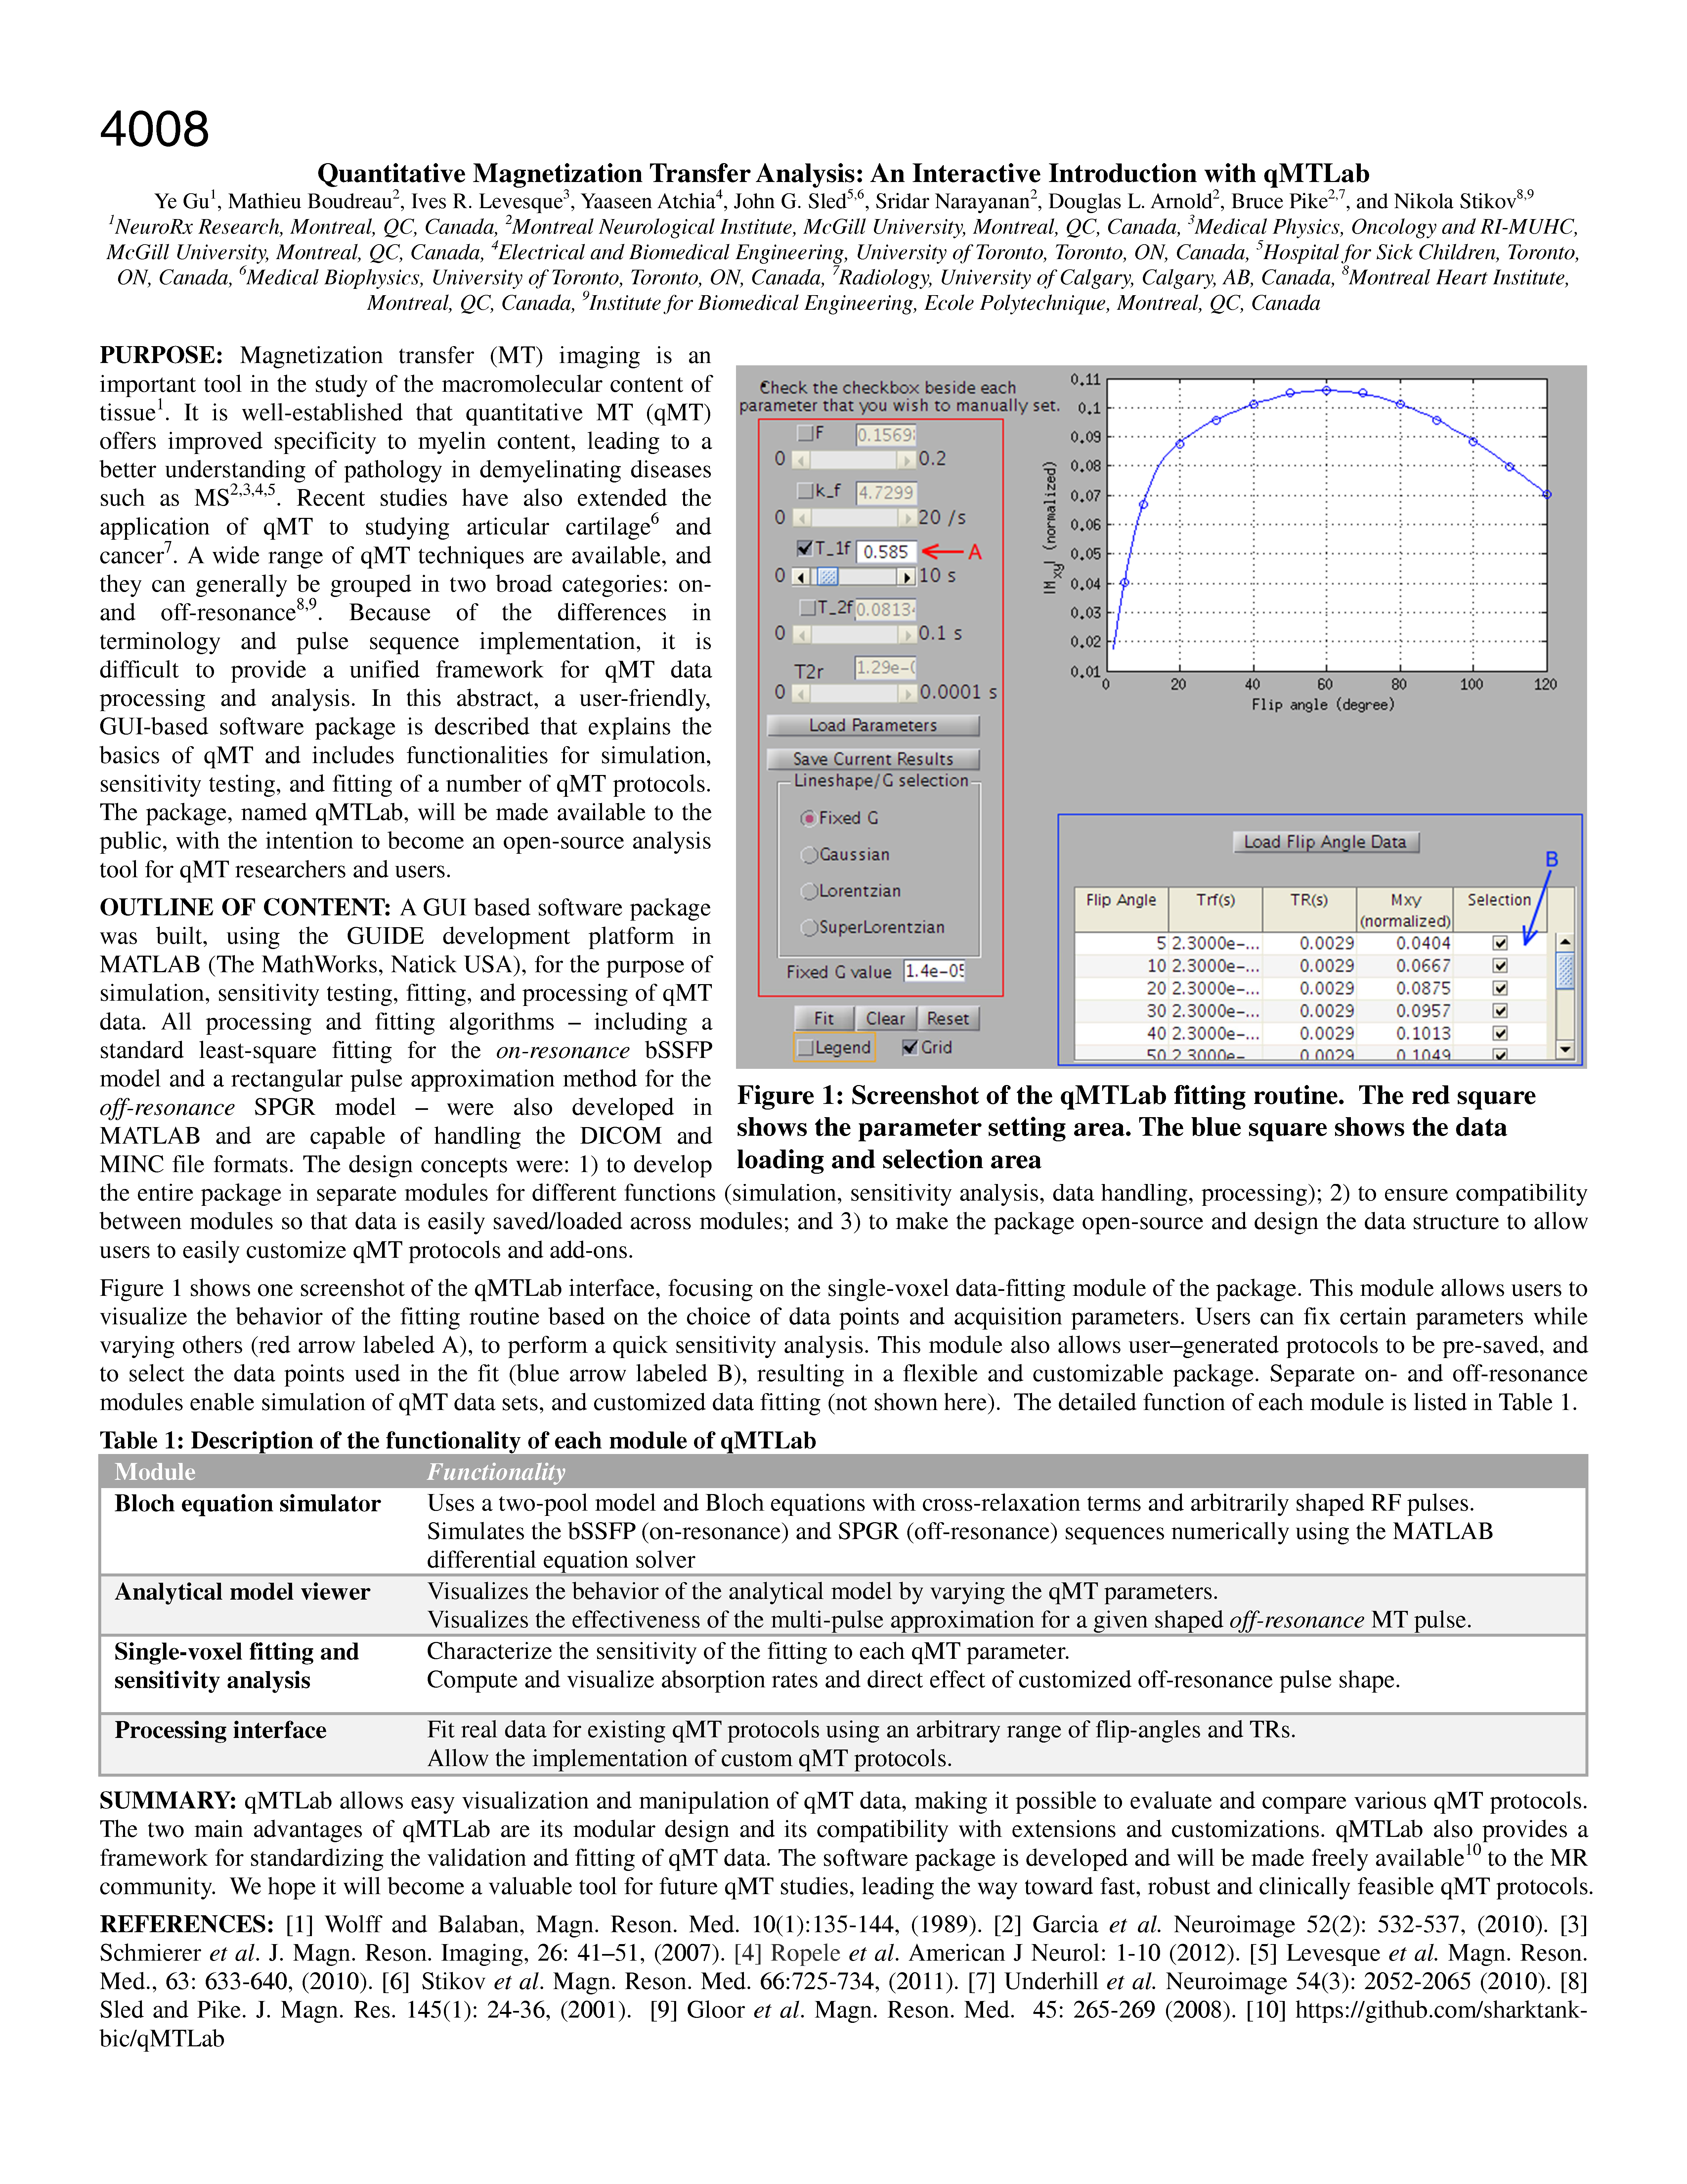

**APENDIX D**

**In vivo histology of the myelin g-ratio with magnetic resonance imaging - Neuroimage**

**(Submitted, coauthor)**

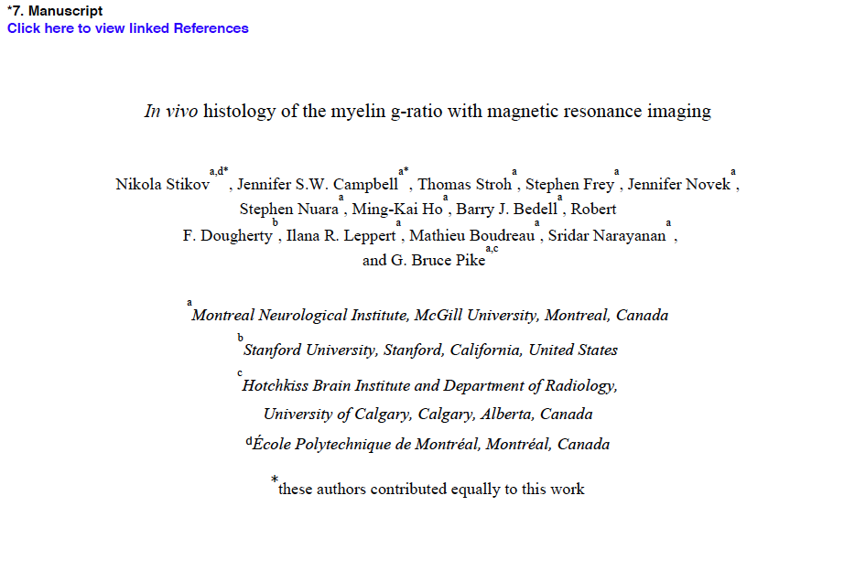

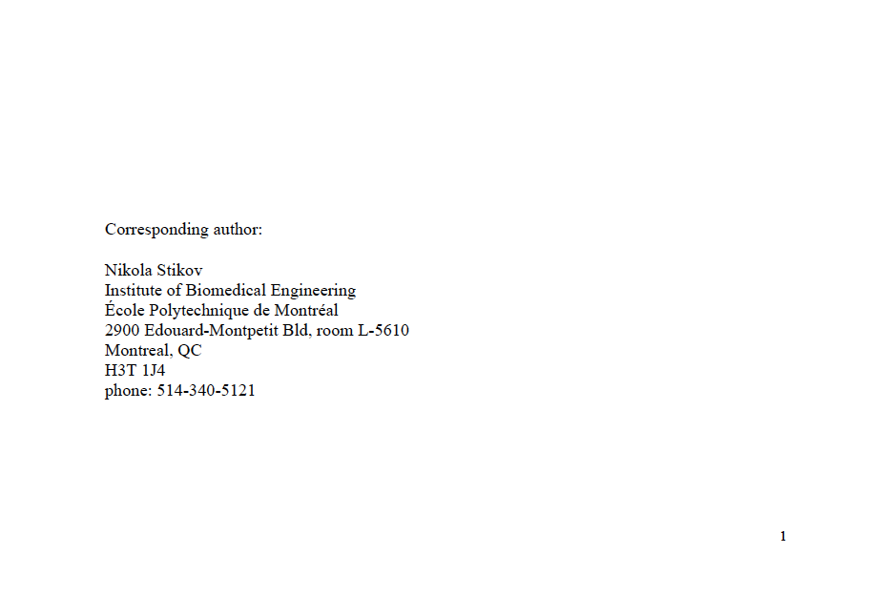

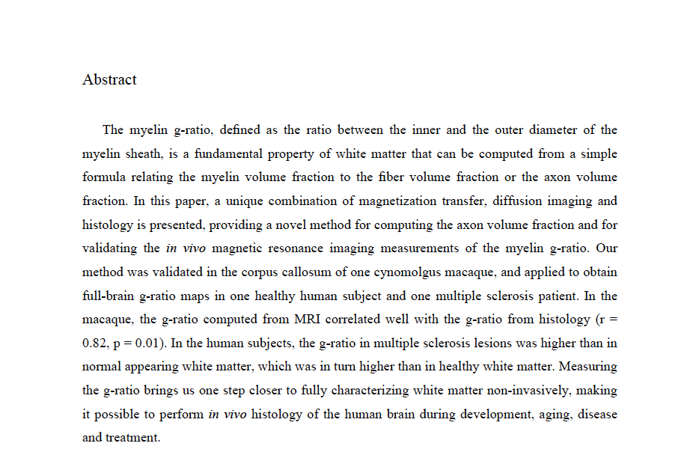

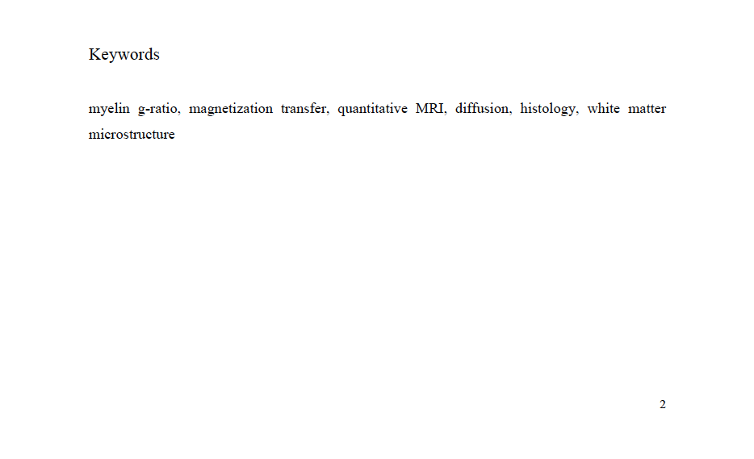

**References**

1. MSSC. <http://www.mssociety.ca/en/information>. MS Society of Canada 2012.

2. Polman CH, Reingold SC, Banwell B, Clanet M, Cohen JA, Filippi M, Fujihara K, Havrdova E, Hutchinson M, Kappos L, Lublin FD, Montalban X, O'Connor P, Sandberg-Wollheim M, Thompson AJ, Waubant E, Weinshenker B, Wolinsky JS. Diagnostic criteria for multiple sclerosis: 2010 revisions to the McDonald criteria. Ann Neurol 2011;69(2):292-302.

3. Frohman EM, Racke MK, Raine CS. Multiple sclerosis--the plaque and its pathogenesis. The New England journal of medicine 2006;354(9):942-955.

4. McFarland HF, Martin R. Multiple sclerosis: a complicated picture of autoimmunity. Nature immunology 2007;8(9):913-919.

5. Noseworthy JH, Lucchinetti C, Rodriguez M, Weinshenker BG. Multiple sclerosis. The New England journal of medicine 2000;343(13):938-952.

6. Peterson JW, Bo L, Mork S, Chang A, Trapp BD. Transected neurites, apoptotic neurons, and reduced inflammation in cortical multiple sclerosis lesions. Ann Neurol 2001;50(3):389-400.

7. Schmierer K, Thavarajah JR, An SF, Brandner S, Miller DH, Tozer DJ. Effects of formalin fixation on magnetic resonance indices in multiple sclerosis cortical gray matter. Journal of magnetic resonance imaging : JMRI 2010;32(5):1054-1060.

8. Stadelmann C, Albert M, Wegner C, Bruck W. Cortical pathology in multiple sclerosis. Current opinion in neurology 2008;21(3):229-234.

9. Perry VH, Anthony DC. Axon damage and repair in multiple sclerosis. Philosophical transactions of the Royal Society of London Series B, Biological sciences 1999;354(1390):1641-1647.

10. Lassmann H. Axonal and neuronal pathology in multiple sclerosis: What have we learnt from animal models. Experimental neurology 2010;225(1):2-8.

11. Staugaitis SM, Chang A, Trapp BD. Cortical pathology in multiple sclerosis: experimental approaches to studies on the mechanisms of demyelination and remyelination. Acta Neurologica Scandinavica 2012;126:97-102.

12. Klaver R, De Vries HE, Schenk GJ, Geurts JJ. Grey matter damage in multiple sclerosis: A pathology perspective. Prion 2013;7(1).

13. Brownell B, Hughes JT. The distribution of plaques in the cerebrum in multiple sclerosis. Journal of neurology, neurosurgery, and psychiatry 1962;25:315-320.

14. Calabrese M, Agosta F, Rinaldi F, Mattisi I, Grossi P, Favaretto A, Atzori M, Bernardi V, Barachino L, Rinaldi L, Perini P, Gallo P, Filippi M. Cortical Lesions and Atrophy Associated With Cognitive Impairment in Relapsing-Remitting Multiple Sclerosis. Archives of neurology 2009;66(9):1144-1150.

15. Simon JH, Li D, Traboulsee A, Coyle PK, Arnold DL, Barkhof F, Frank JA, Grossman R, Paty DW, Radue EW, Wolinsky JS. Standardized MR imaging protocol for multiple sclerosis: Consortium of MS Centers consensus guidelines. AJNR American journal of neuroradiology 2006;27(2):455-461.

16. Schmierer K, Scaravilli F, Altmann DR, Barker GJ, Miller DH. Magnetization transfer ratio and myelin in postmortem multiple sclerosis brain. Ann Neurol 2004;56(3):407-415.

17. Schmierer K, Tozer DJ, Scaravilli F, Altmann DR, Barker GJ, Tofts PS, Miller DH. Quantitative magnetization transfer imaging in postmortem multiple sclerosis brain. Journal of magnetic resonance imaging : JMRI 2007;26(1):41-51.

18. Levesque I, Sled JG, Narayanan S, Santos AC, Brass SD, Francis SJ, Arnold DL, Pike GB. The role of edema and demyelination in chronic T-1 black holes: A quantitative magnetization transfer study. Journal of Magnetic Resonance Imaging 2005;21(2):103-110.

19. Levesque IR, Giacomini PS, Narayanan S, Ribeiro LT, Sled JG, Arnold DL, Pike GB. Quantitative magnetization transfer and myelin water imaging of the evolution of acute multiple sclerosis lesions. Magnetic resonance in medicine : official journal of the Society of Magnetic Resonance in Medicine / Society of Magnetic Resonance in Medicine 2010;63(3):633-640.

20. Tardif CL, Bedell BJ, Eskildsen SF, Collins DL, Pike GB. Quantitative Magnetic Resonance Imaging of Cortical Multiple Sclerosis Pathology. Multiple Sclerosis International 2012;2012:13.

21. Arnold DL, Matthews PM. MRI in the diagnosis and management of multiple sclerosis. Neurology 2002;58(8 suppl 4):S23-S31.

22. Anderson VM, Fox NC, Miller DH. Magnetic resonance imaging measures of brain atrophy in multiple sclerosis. Journal of Magnetic Resonance Imaging 2006;23(5):605-618.

23. De Stefano N, Battaglini M, Smith SM. Measuring Brain Atrophy in Multiple Sclerosis. Journal of Neuroimaging 2007;17:10S-15S.

24. Sepulcre J, Goni J, Masdeu JC, Bejarano B, de Mendizabal NV, Toledo JB, Villoslada P. Contribution of White Matter Lesions to Gray Matter Atrophy in Multiple Sclerosis. Archives of neurology 2009;66(2):173-179.

25. Derakhshan M, Caramanos Z, Giacomini PS, Narayanan S, Maranzano J, Francis SJ, Arnold DL, Collins DL. Evaluation of automated techniques for the quantification of grey matter atrophy in patients with multiple sclerosis. NeuroImage 2010;52(4):1261-1267.

26. Filippi M, Agosta F. Magnetic resonance techniques to quantify tissue damage, tissue repair, and functional cortical reorganization in multiple sclerosis. Progress in brain research 2009;175:465-482.

27. Kidd D, Barkhof F, McConnell R, Algra PR, Allen IV, Revesz T. Cortical lesions in multiple sclerosis. Brain : a journal of neurology 1999;122 ( Pt 1):17-26.

28. Bedell BJ, Narayana PA. Implementation and evaluation of a new pulse sequence for rapid acquisition of double inversion recovery images for simultaneous suppression of white matter and CSF. Journal of magnetic resonance imaging : JMRI 1998;8(3):544-547.

29. Filippi M, Rocca MA. Multiple sclerosis and allied white matter diseases. Neurological sciences : official journal of the Italian Neurological Society and of the Italian Society of Clinical Neurophysiology 2008;29 Suppl 3:319-322.

30. Wolff SD, Balaban RS. Magnetization transfer contrast (MTC) and tissue water proton relaxation in vivo. Magnetic resonance in medicine : official journal of the Society of Magnetic Resonance in Medicine / Society of Magnetic Resonance in Medicine 1989;10(1):135-144.

31. Henkelman RM, Huang X, Xiang QS, Stanisz GJ, Swanson SD, Bronskill MJ. Quantitative interpretation of magnetization transfer. Magnetic resonance in medicine : official journal of the Society of Magnetic Resonance in Medicine / Society of Magnetic Resonance in Medicine 1993;29(6):759-766.

32. Graham SJ, Henkelman RM. Understanding pulsed magnetization transfer. Journal of magnetic resonance imaging : JMRI 1997;7(5):903-912.

33. Henkelman RM, Stanisz GJ, Graham SJ. Magnetization transfer in MRI: a review. NMR in biomedicine 2001;14(2):57-64.

34. Ge Y, Kolson DL, Babb JS, Mannon LJ, Grossman RI. Whole brain imaging of HIV-infected patients: quantitative analysis of magnetization transfer ratio histogram and fractional brain volume. AJNR American journal of neuroradiology 2003;24(1):82-87.

35. Dousset V, Armand JP, Huot P, Viaud B, Caille JM. Magnetization transfer imaging in AIDS-related brain diseases. Neuroimaging clinics of North America 1997;7(3):447-460.

36. Wu Y, Storey P, Carrillo A, Saglamer C, Cohen BA, Epstein LG, Edelman RR, Ragin AB. Whole brain and localized magnetization transfer measurements are associated with cognitive impairment in patients infected with human immunodeficiency virus. AJNR American journal of neuroradiology 2008;29(1):140-145.

37. Fornari E, Maeder P, Meuli R, Ghika J, Knyazeva MG. Demyelination of superficial white matter in early Alzheimer's disease: a magnetization transfer imaging study. Neurobiology of aging 2012;33(2):428 e427-419.

38. Giulietti G, Bozzali M, Figura V, Spano B, Perri R, Marra C, Lacidogna G, Giubilei F, Caltagirone C, Cercignani M. Quantitative magnetization transfer provides information complementary to grey matter atrophy in Alzheimer's disease brains. Neuroimage 2012;59(2):1114-1122.

39. Ridha BH, Tozer DJ, Symms MR, Stockton KC, Lewis EB, Siddique MM, MacManus DG, Rossor MN, Fox NC, Tofts PS. Quantitative magnetization transfer imaging in Alzheimer disease. Radiology 2007;244(3):832-837.

40. Wiest R, Burren Y, Hauf M, Schroth G, Pruessner J, Zbinden M, Cattapan-Ludewig K, Kiefer C. Classification of mild cognitive impairment and Alzheimer disease using model-based MR and magnetization transfer imaging. AJNR American journal of neuroradiology 2013;34(4):740-746.

41. Li X, Majumdar S. Quantitative MRI of articular cartilage and its clinical applications. Journal of magnetic resonance imaging : JMRI 2013;38(5):991-1008.

42. Stikov N, Keenan KE, Pauly JM, Smith RL, Dougherty RF, Gold GE. Cross-relaxation imaging of human articular cartilage. Magnetic resonance in medicine : official journal of the Society of Magnetic Resonance in Medicine / Society of Magnetic Resonance in Medicine 2011;66(3):725-734.

43. Sled JG, Pike GB. Quantitative imaging of magnetization transfer exchange and relaxation properties in vivo using MRI. Magnetic resonance in medicine : official journal of the Society of Magnetic Resonance in Medicine / Society of Magnetic Resonance in Medicine 2001;46(5):923-931.

44. Yarnykh VL. Pulsed Z-spectroscopic imaging of cross-relaxation parameters in tissues for human MRI: theory and clinical applications. Magnetic resonance in medicine : official journal of the Society of Magnetic Resonance in Medicine / Society of Magnetic Resonance in Medicine 2002;47(5):929-939.

45. Cercignani M, Alexander DC. Optimal acquisition schemes for in vivo quantitative magnetization transfer MRI. Magnetic resonance in medicine : official journal of the Society of Magnetic Resonance in Medicine / Society of Magnetic Resonance in Medicine 2006;56(4):803-810.

46. Portnoy S, Stanisz GJ. Modeling pulsed magnetization transfer. Magnetic resonance in medicine : official journal of the Society of Magnetic Resonance in Medicine / Society of Magnetic Resonance in Medicine 2007;58(1):144-155.

47. Ramani A, Dalton C, Miller DH, Tofts PS, Barker GJ. Precise estimate of fundamental in-vivo MT parameters in human brain in clinically feasible times. Magnetic resonance imaging 2002;20(10):721-731.

48. Levesque IR, Sled JG, Narayanan S, Giacomini PS, Ribeiro LT, Arnold DL, Pike GB. Reproducibility of quantitative magnetization-transfer imaging parameters from repeated measurements. Magnetic resonance in medicine : official journal of the Society of Magnetic Resonance in Medicine / Society of Magnetic Resonance in Medicine 2010;64(2):391-400.

49. Levesque IR, Sled JG, Pike GB. Iterative optimization method for design of quantitative magnetization transfer imaging experiments. Magnetic resonance in medicine : official journal of the Society of Magnetic Resonance in Medicine / Society of Magnetic Resonance in Medicine 2011;66(3):635-643.

50. Yarnykh VL. Fast macromolecular proton fraction mapping from a single off-resonance magnetization transfer measurement. Magnetic resonance in medicine : official journal of the Society of Magnetic Resonance in Medicine / Society of Magnetic Resonance in Medicine 2012;68(1):166-178.

51. Underhill HR, Rostomily RC, Mikheev AM, Yuan C, Yarnykh VL. Fast bound pool fraction imaging of the in vivo rat brain: association with myelin content and validation in the C6 glioma model. NeuroImage 2011;54(3):2052-2065.

52. Gloor M, Scheffler K, Bieri O. Quantitative magnetization transfer imaging using balanced SSFP. Magnetic resonance in medicine : official journal of the Society of Magnetic Resonance in Medicine / Society of Magnetic Resonance in Medicine 2008;60(3):691-700.

53. Lustig M, Donoho D, Pauly JM. Sparse MRI: The application of compressed sensing for rapid MR imaging. Magnetic resonance in medicine : official journal of the Society of Magnetic Resonance in Medicine / Society of Magnetic Resonance in Medicine 2007;58(6):1182-1195.

54. Gamper U, Boesiger P, Kozerke S. Compressed sensing in dynamic MRI. Magnetic resonance in medicine : official journal of the Society of Magnetic Resonance in Medicine / Society of Magnetic Resonance in Medicine 2008;59(2):365-373.

55. Menzel MI, Tan ET, Khare K, Sperl JI, King KF, Tao XD, Hardy CJ, Marinelli L. Accelerated Diffusion Spectrum Imaging in the Human Brain Using Compressed Sensing. Magnetic Resonance in Medicine 2011;66(5):1226-1233.

56. Doneva M, Bornert P, Eggers H, Stehning C, Senegas J, Mertins A. Compressed sensing reconstruction for magnetic resonance parameter mapping. Magnetic resonance in medicine : official journal of the Society of Magnetic Resonance in Medicine / Society of Magnetic Resonance in Medicine 2010;64(4):1114-1120.

57. Li W, Griswold M, Yu X. Fast cardiac T(1) mapping in mice using a model-based compressed sensing method. Magnetic resonance in medicine : official journal of the Society of Magnetic Resonance in Medicine / Society of Magnetic Resonance in Medicine 2011.

58. Sumpf TJ, Uecker M, Boretius S, Frahm J. Model-Based Nonlinear Inverse Reconstruction for T2 Mapping Using Highly Undersampled Spin-Echo MRI. Journal of Magnetic Resonance Imaging 2011;34(2):420-428.

59. Ji SH, Xue Y, Carin L. Bayesian compressive sensing. Ieee T Signal Proces 2008;56(6):2346-2356.

60. Bilgic B, Goyal VK, Adalsteinsson E. Multi-contrast reconstruction with Bayesian compressed sensing. Magnetic resonance in medicine : official journal of the Society of Magnetic Resonance in Medicine / Society of Magnetic Resonance in Medicine 2011;66(6):1601-1615.

61. Lustig M, Pauly JM. SPIRiT: Iterative self-consistent parallel imaging reconstruction from arbitrary k-space. Magnetic resonance in medicine : official journal of the Society of Magnetic Resonance in Medicine / Society of Magnetic Resonance in Medicine 2010;64(2):457-471.

62. Uecker M, Lai P, Murphy MJ, Virtue P, Elad M, Pauly JM, Vasanawala SS, Lustig M. ESPIRiT—an eigenvalue approach to autocalibrating parallel MRI: Where SENSE meets GRAPPA. Magnetic Resonance in Medicine 2013:n/a-n/a.

63. Weller DS, Polimeni JR, Grady L, Wald LL, Adalsteinsson E, Goyal VK. Combined Compressed Sensing and Parallel Mri Compared for Uniform and Random Cartesian Undersampling of K-Space. 2011 Ieee International Conference on Acoustics, Speech, and Signal Processing 2011:553-556.

64. She H, Chen R-R, Liang D, DiBella EVR, Ying L. Sparse BLIP: BLind Iterative Parallel imaging reconstruction using compressed sensing. Magnetic Resonance in Medicine 2013:n/a-n/a.

65. Wu B, Millane RP, Watts R, Bones PJ. Prior estimate-based compressed sensing in parallel MRI. Magnetic resonance in medicine : official journal of the Society of Magnetic Resonance in Medicine / Society of Magnetic Resonance in Medicine 2011;65(1):83-95.

66. Chang CH, Ji J. Compressed Sensing MRI with Multichannel Data Using Multicore Processors. Magnetic Resonance in Medicine 2010;64(4):1135-1139.

67. Liang D, Liu B, Wang JJ, Ying L. Accelerating SENSE Using Compressed Sensing. Magnetic Resonance in Medicine 2009;62(6):1574-1584.

68. Liu B, Zou YM, Ying L. SparseSENSE: Application of compressed sensing in parallel MRI. 2008 International Special Topic Conference on Information Technology and Applications in Biomedicine, Vols 1 and 2 2008:261-264.

69. Ji JX, Zhao C, Lang T. Compressed Sensing Parallel Magnetic Resonance Imaging. 2008 30th Annual International Conference of the IEEE Engineering in Medicine and Biology Society, Vols 1-8 2008:1671-1674.

70. Stikov N, Boudreau M, Levesque IR, Tardif CL, Barral JK, Pike GB. On the accuracy of T mapping: Searching for common ground. Magnetic resonance in medicine : official journal of the Society of Magnetic Resonance in Medicine / Society of Magnetic Resonance in Medicine 2014.

71. Sacolick LI, Wiesinger F, Hancu I, Vogel MW. B1 mapping by Bloch-Siegert shift. Magnetic resonance in medicine : official journal of the Society of Magnetic Resonance in Medicine / Society of Magnetic Resonance in Medicine 2010;63(5):1315-1322.

72. Yarnykh VL. Optimal radiofrequency and gradient spoiling for improved accuracy of T1 and B1 measurements using fast steady-state techniques. Magnetic resonance in medicine : official journal of the Society of Magnetic Resonance in Medicine / Society of Magnetic Resonance in Medicine 2010;63(6):1610-1626.

73. Yarnykh VL. Actual flip-angle imaging in the pulsed steady state: a method for rapid three-dimensional mapping of the transmitted radiofrequency field. Magnetic resonance in medicine : official journal of the Society of Magnetic Resonance in Medicine / Society of Magnetic Resonance in Medicine 2007;57(1):192-200.

74. Cruz JB. System sensitivity analysis: Dowden, Hutchinson & Ross; 1973.

75. Mezer A, Yeatman JD, Stikov N, Kay KN, Cho NJ, Dougherty RF, Perry ML, Parvizi J, Hua le H, Butts-Pauly K, Wandell BA. Quantifying the local tissue volume and composition in individual brains with magnetic resonance imaging. Nature medicine 2013;19(12):1667-1672.

76. Zhang T, Pauly J, Levesque I. Accelerating Parameter Mapping with a Locally Low Rank Constraint. In Proceedings of the 21st Annual Meeting of ISMRM 2013:p.2458.